**LABSHEET 06**

1.

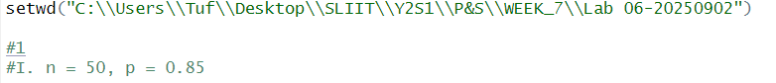

2.

